DATA VISUALIZATION ASSIGNMENT-5

DATA BLENDING

GROUP-6

Yashwanth Reddy Sankepally-11507775

Srujan Reddy Rachuri-11526547

TejaKiran Jami-11524785

Sheshank Mekala-11548829

Assignment – Data Blending  
1) Download from Canvas the data file – datablending-assignment.twbx  
This is a packaged workbook and should load directly into Tableau by double clicking on the file.  
2) Rename Sheet 2 – Office City Primary  
3) Select Office City  
You should see the data associated with this data source  
Drag Sales to the Columns Shelf  
Drag State to the Rows Shelf  
PLACE A SCREEN SHOT OF THE OUTPUT HERE

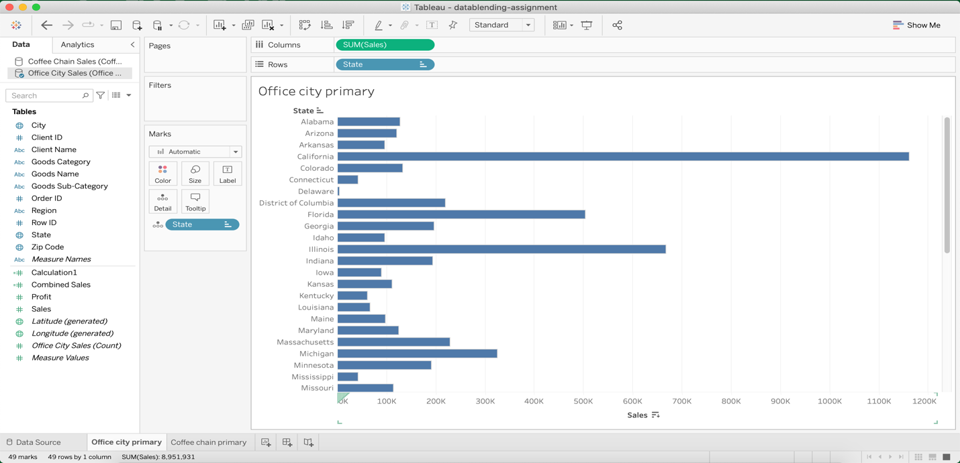

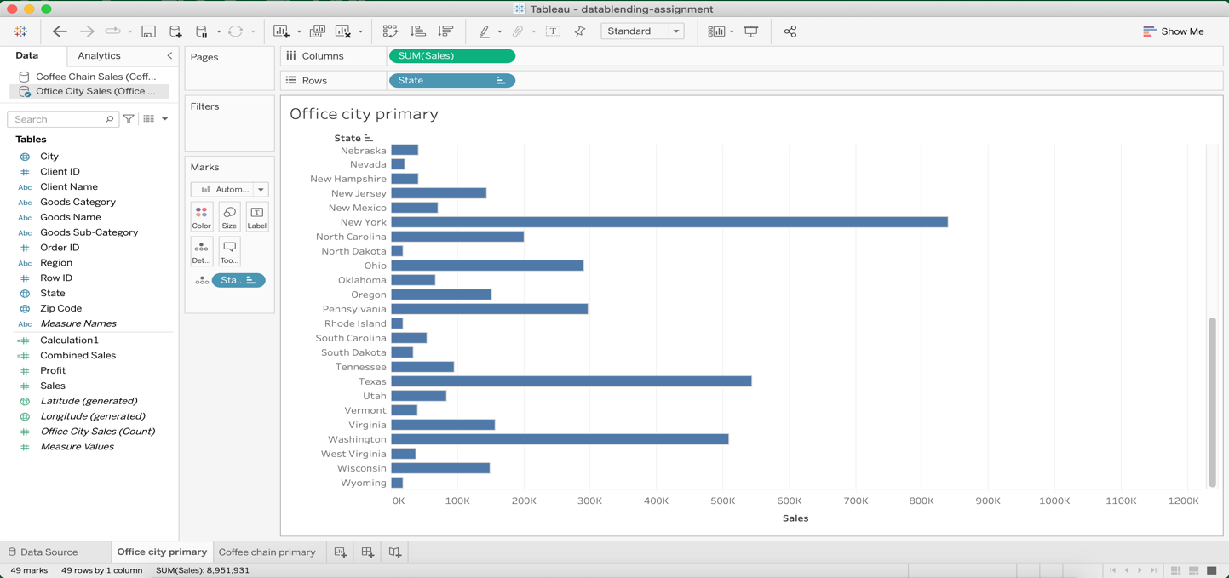

Q1: There are NULL for some of the states for Coffee Chain – why?

**Ans-** In the Sales data, there are 49 US states (48 contiguous states plus the District of Columbia). In the Coffee Chain data, there are 20 states. That leaves 29 states in the Superstore Sales data have no corresponding rows in Coffee Chain. For the States set calculation, Tableau assigns a value of Null to those 29 states because they don’t have corresponding values.

5) Create a new sheet  
6) Name the sheet – Coffee Chain Primary  
7) Select Coffee Chain  
You should see the data associated with this data source  
Drag Sales to the Column Shelf   
Drag State to the Column Shelf

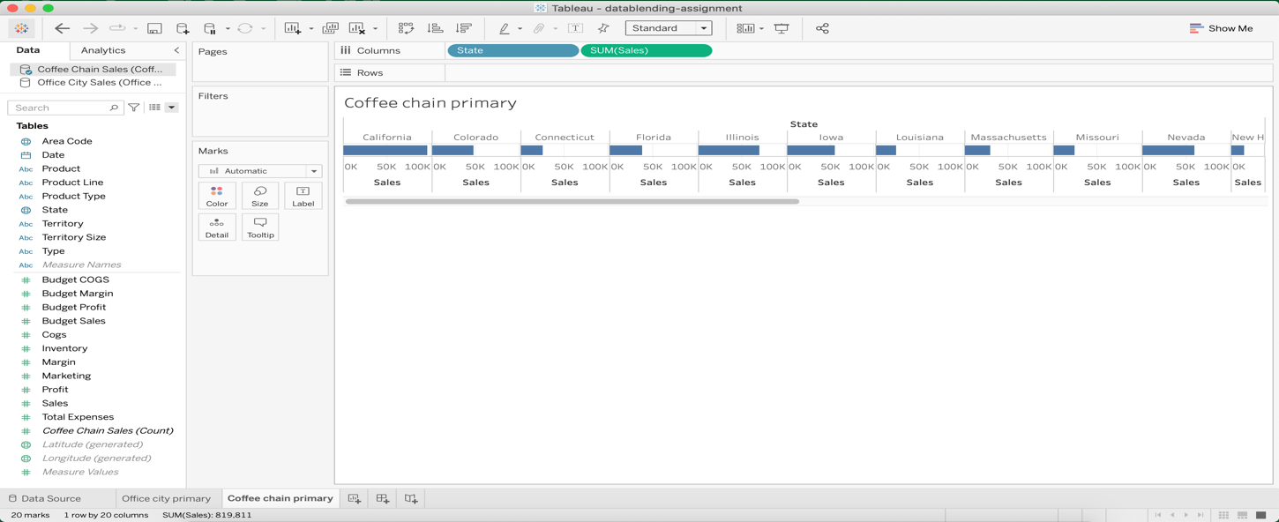

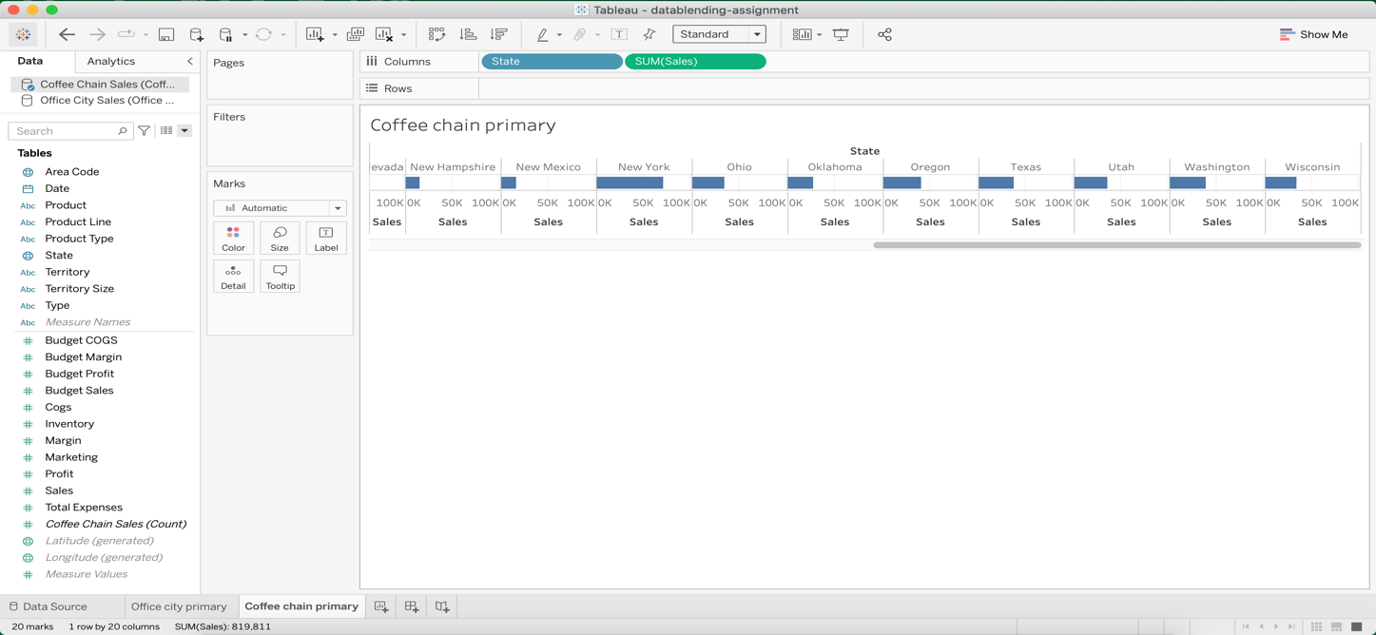

8) Select Office City  
Drag Sales to the Columns Shelf

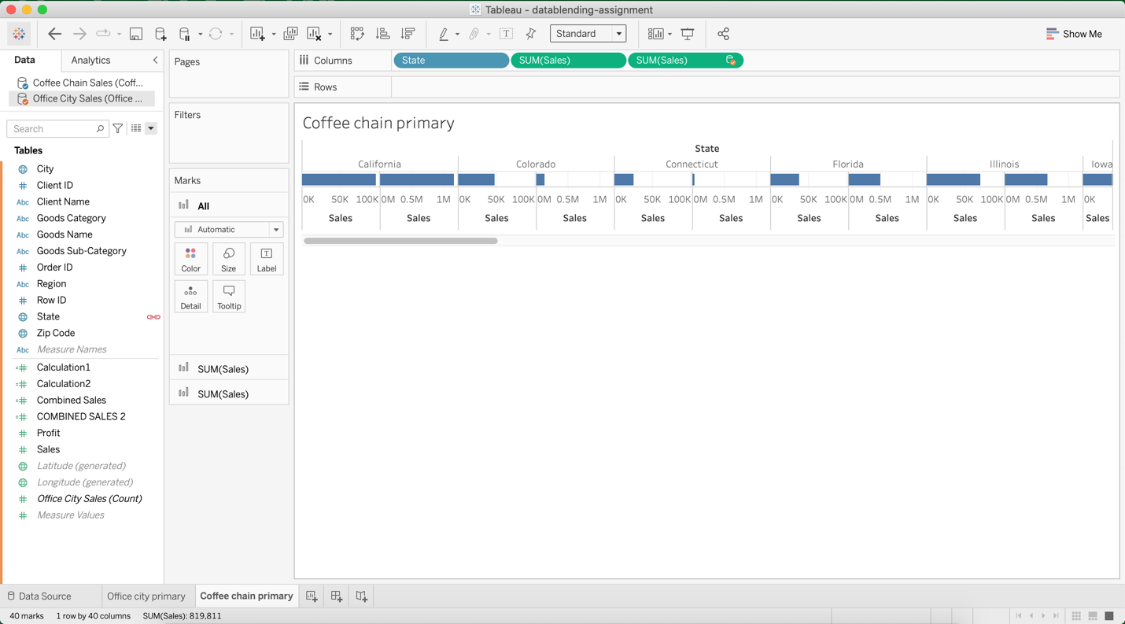

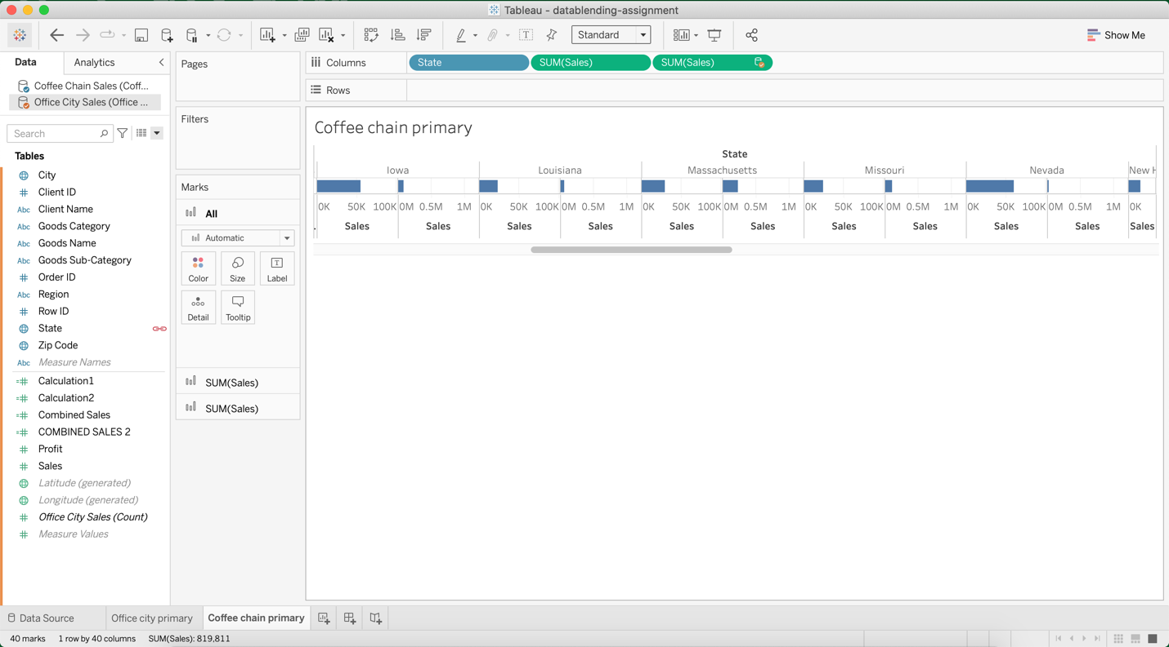

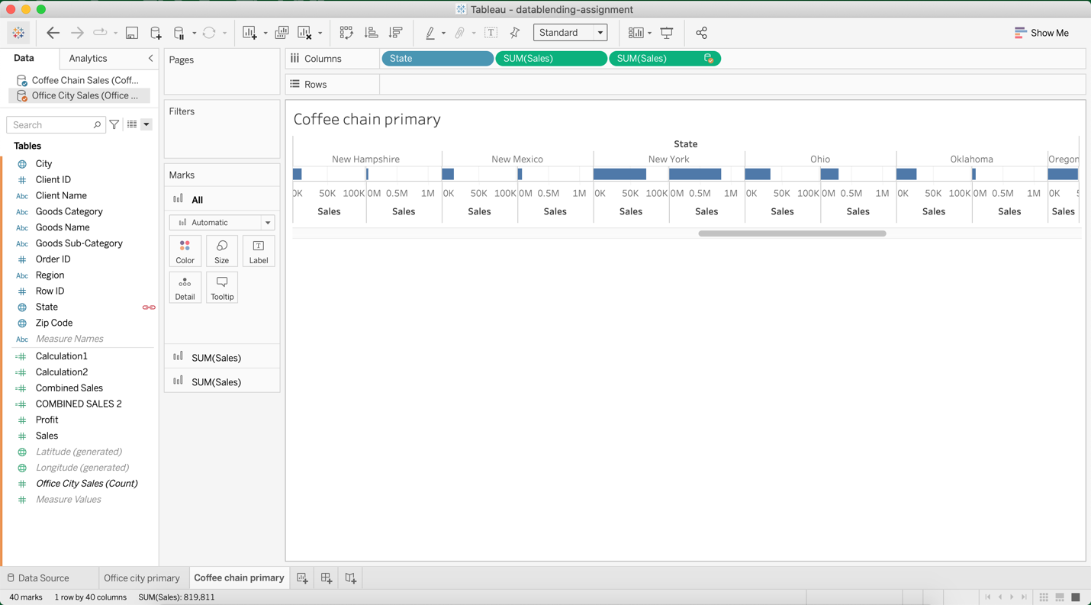

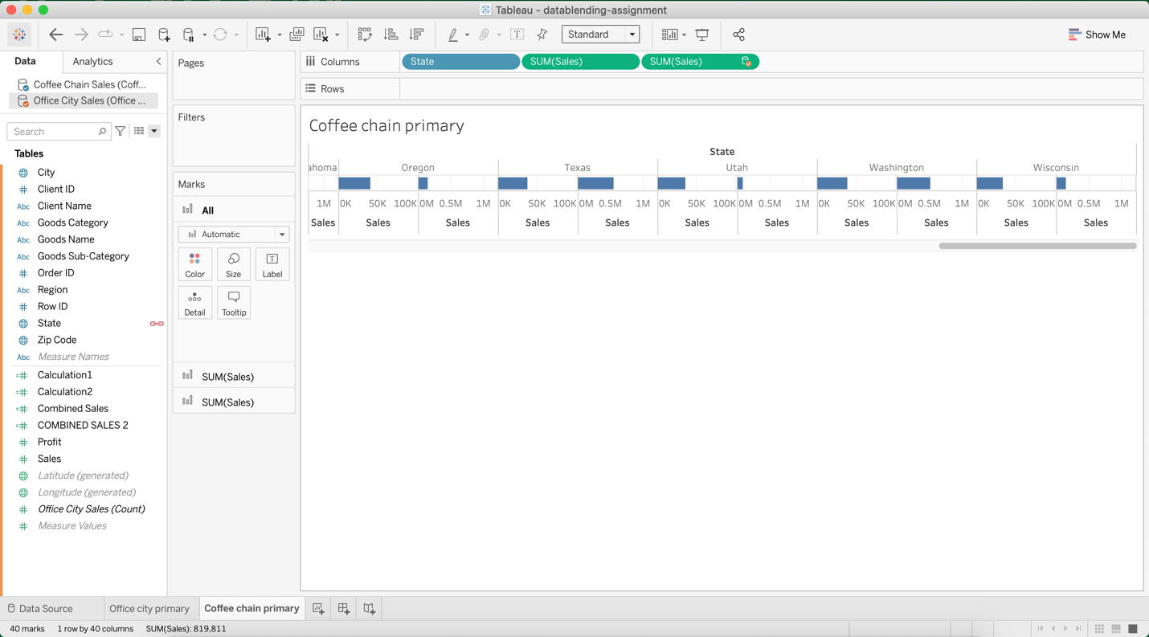

Q2: Are the two sheets different? If so, why?

**Ans:** Both the sheets are different because in the first sheet(Office City Primary) there are 49 states’ sales data but there are only 20 states’ sales data available for Coffee chain primary remaining states’ data are shown as Null values.

Whereas in the second sheet(Coffee chain primary) there are 20states’ data available so the matching states’ data from Office City are shown.

9) Go back to the “Office City Primary” sheet  
10) Create a Calculated Field that will combine the sales from   
the two data source  
Select Office City  
Right Click in the dimension/measurement area  
Select “Create Calculated Field”  
Drag Sales to the Formula Box   
Add a + sign  
Select Coffee Chain  
Drag Sales to the Formula Box

11) Wrap the first argument in a SUM aggregate   
12) Rename your calculated field Combined Sales  
13) Click Okay  
14) Drag Combined Sales to the Columns Shelf

PLACE A SCREEN SHOT OF THE OUTPUT HERE

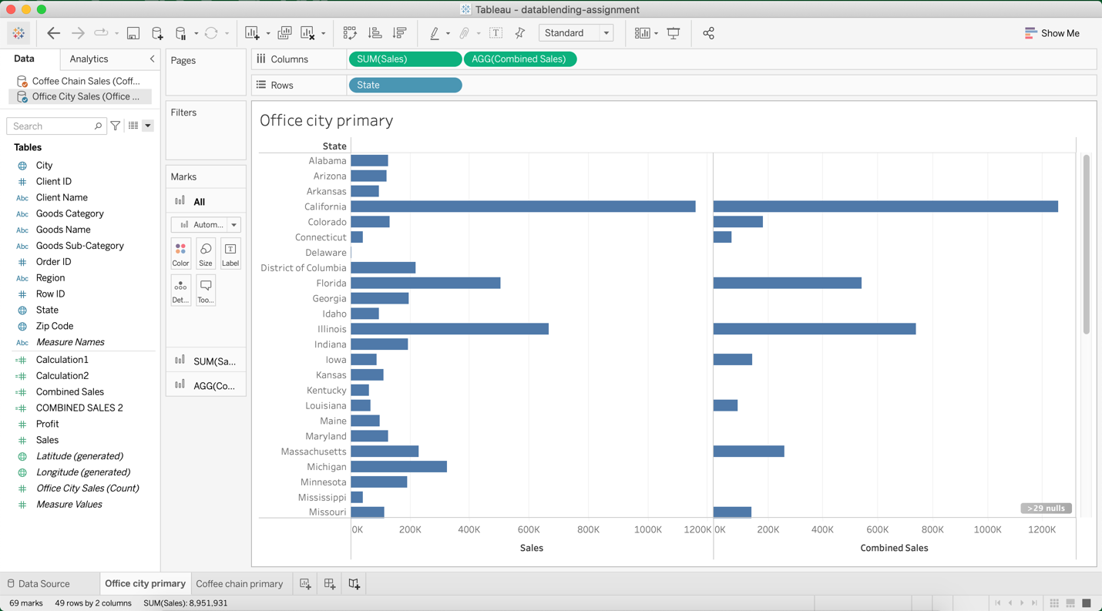

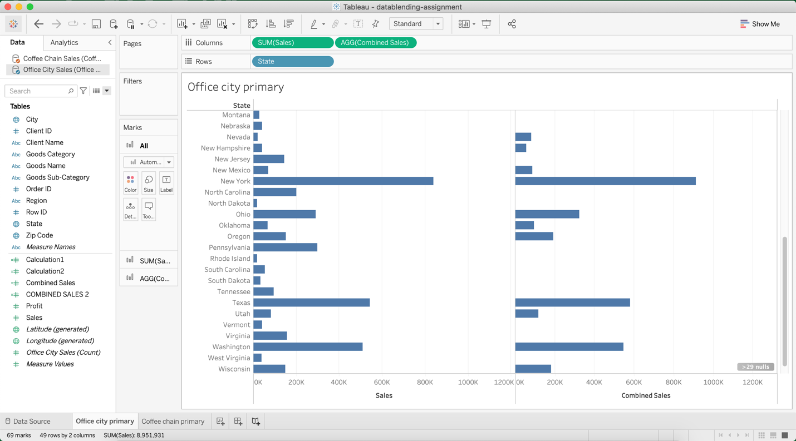

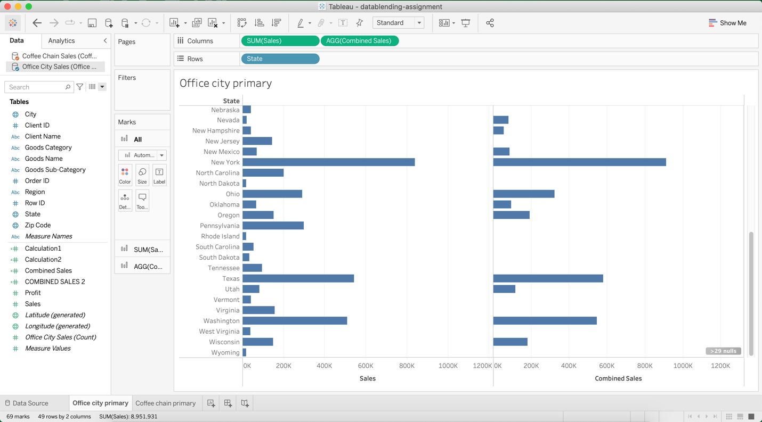

Q3: Notice there is an Error in the calculation – why is this an error? (Look at the pull down – it will tell you)

**Ans-**The error has occurred because tableau cannot mix aggregate & non-aggregate arguments with this function.

Q4: Is your combined sales function returning what you expected? Why/why not?

**Ans-**The combined sales function is returning what we thought of as we there are null values in Coffee chain Sales for certain states so this these states’ combined sales will return null value.

15) Click on your Combined Sales field and select EDIT  
16) Edit the formula to add the ZN function to the second argument and select OK

PLACE A SCREEN SHOT OF THE OUTPUT HERE

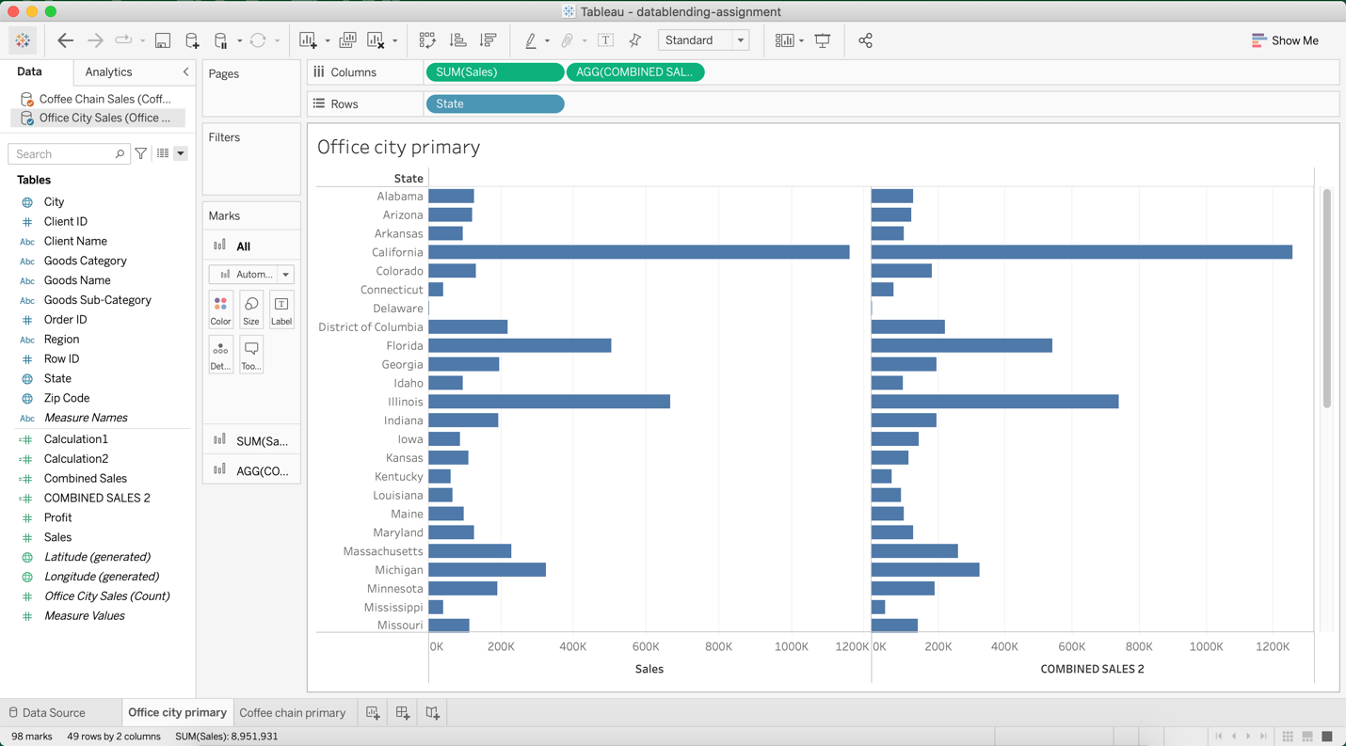

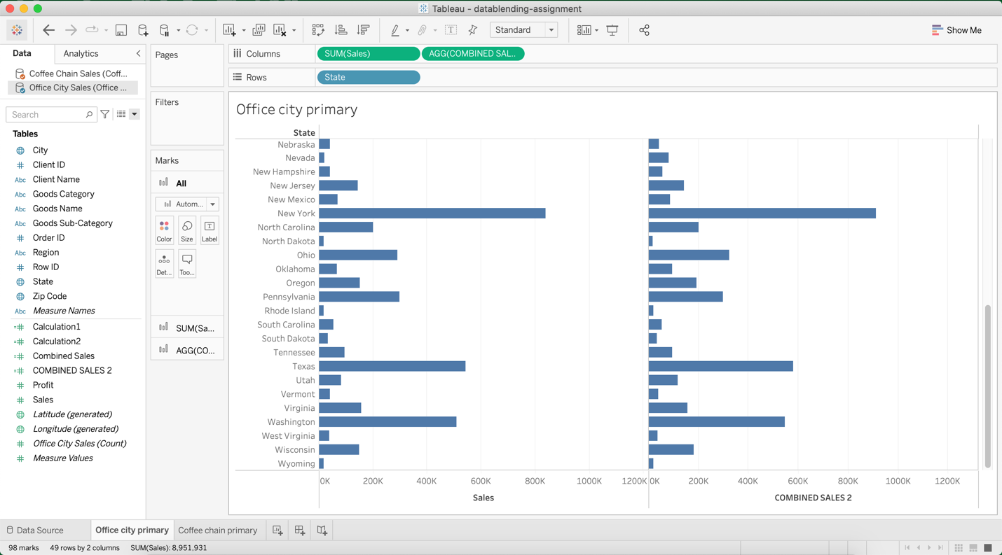

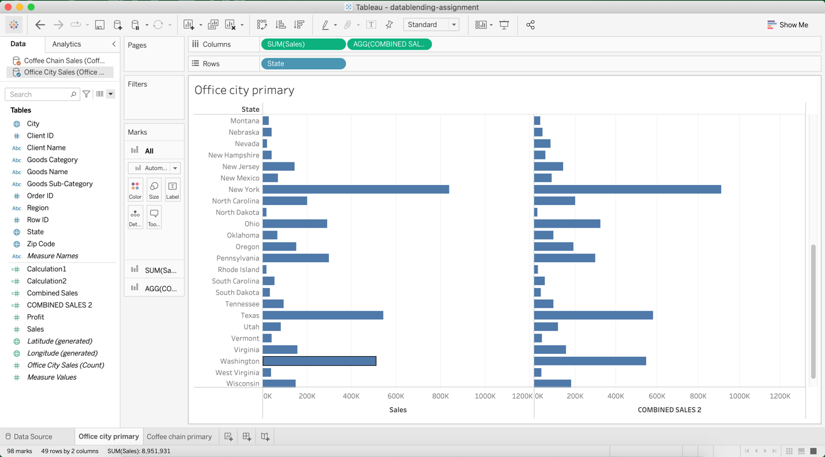

Q5: Is your combined sales function returning what you expected? Why/why not?

**Ans-**The ZN function converts all the null values in to Zero(0) so we expected the Combined sales result to be sum of the sales of Office City & Coffee Chain.

